Name: ____________________________ Date: ________________ Period: ______

Chemical Bonding Study Guide

Vocabulary: Match the following vocabulary words with their definitions
- Electron Cloud  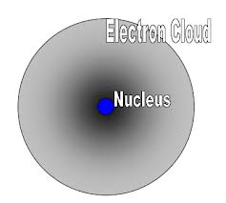 _______ | - Atom that is no longer neutral because it has gained or lost electrons
- Electron Dot Diagram  _______ | - Pure substance that contains two or more elements, created when atoms bond
- Ion  _______ | - Neutral particle formed when atoms bond together
- Molecule  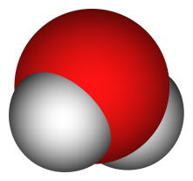 _______ | - Area where electrons travel around the nucleus
- Compound  _______ | - Element symbol surrounded by dots to show the number of valence electrons
- Chemical Bond  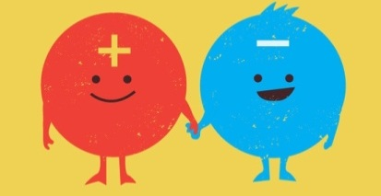 _______ | - Chemical bond that holds atoms together by the attraction of opposite charges
- Ionic Bond  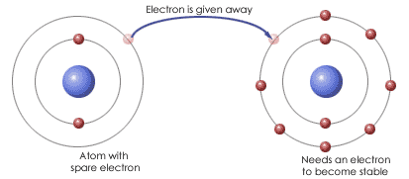 _______ | - Chemical bond that holds atoms together by sharing electrons
- Metallic Bond  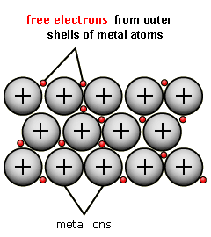 _______ | - Chemical bond created when atoms share electrons unequally
- Covalent Bond  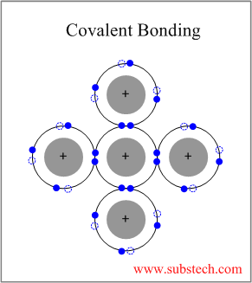 _______ | - Force that holds two atoms together
- Polar Bond  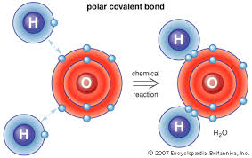 _______ | - Chemical bond that holds atoms together because the atoms are pooling their electrons

Skills and Concepts

- Use the word bank to label the atom below.

Nucleus | Electron | Proton | Neutron

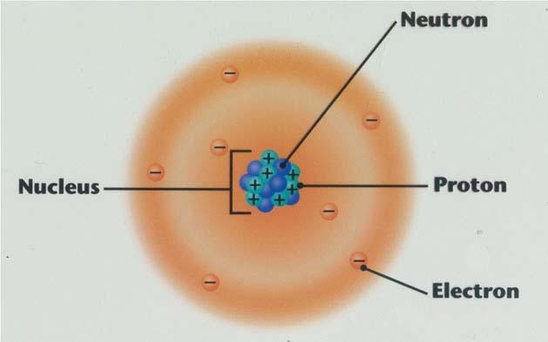

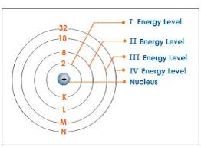
- How many electrons fit in the first, second, third, fourth, and fifth energy levels
- First- 2
- Second-___________
- Third- ___________
- Fourth-___________
- Fifth- 64
- How can you use the periodic table to find the number of electrons in the valence level of an atom?

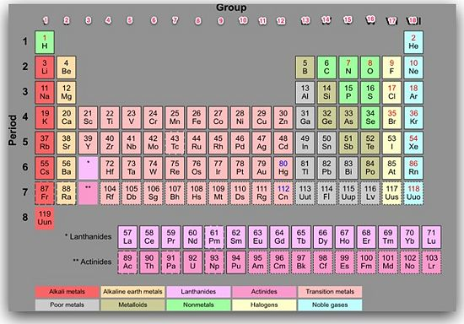

- Number each column on the periodic table of elements from 1 to 18. Hydrogen (H) is at the top of column 1 and helium (He) is at the top of column 18. These are the element groups.
- For groups 1 and 2 look at the top of the table and use the group number
- For groups 13-18 look at the top of the table and use the second digit of the group number
- **This method does not work for groups 3-12 (the transition metals)**

- What makes an atom different from an ion and how does an atom become an ion? Use the words in the word bank to fill in the blanks below.

Particles | Neutral | Charged | Balances
Electrons | Ions | Protons

- Ions and atoms are both ___________________ but ions are ___________________ and atoms are neutral
- Atoms are ___________________ because they have the same number of ___________________ and electrons
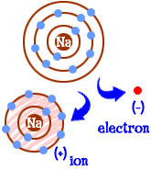
- Atoms become ___________________ when they gain or lose ___________________ because when the number of electrons changes the number of negatives no longer ___________________ the positives

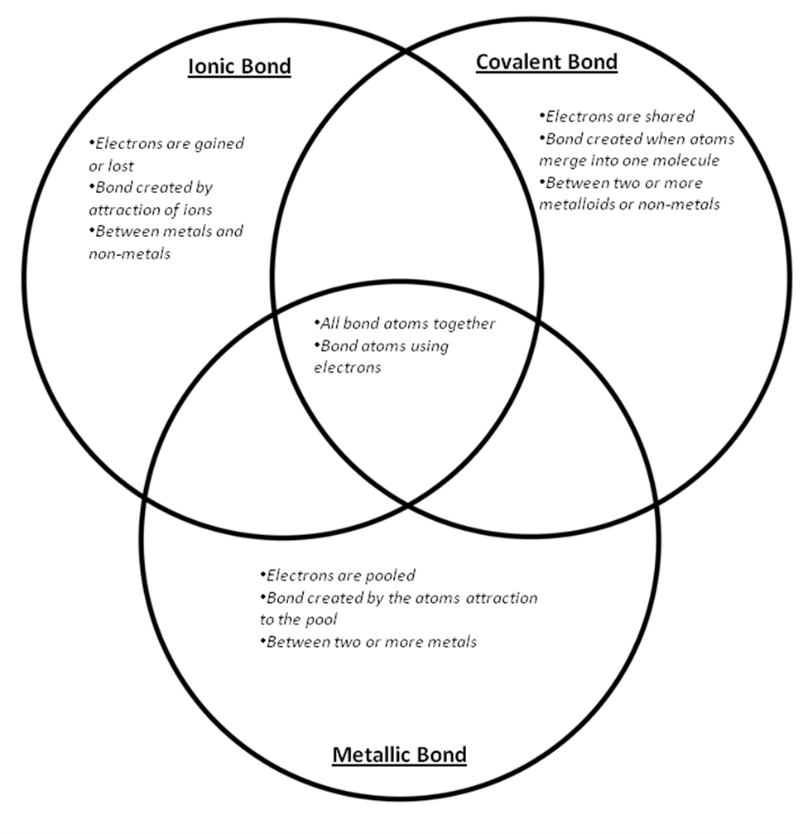
W

Electrons are gained or lost | Bond created by attraction of ions | Between metals and non-metals | Electrons are shared
Bond created when atoms merge into one molecule | Between two or more metalloids or non-metals | All bond atoms together | Bond atoms using electrons
Electrons are pooled | Bond created by the atoms attraction to the pool | Between two or more metals

- What is the difference between an element and compound?

Matter | Bonded | Element

Although an element and a compound are both examples of _____________________, an _____________________ is made of only one kind of atom, while compounds are made of more than one kind of atom _____________________ together.

- Compare and contrast atoms and molecules: Write Atom, molecule, or both next to the following descriptions.
- ________________Neutral particles of matter
- ________________Made up of protons, electrons, and neutrons
- ________________Make up compounds
- ________________Make up elements
- ________________Made of more than one different kind of atom bonded together

- How is a polar bond different from a regular bond? Why?
Evenly | Electrons | Neutral | Stronger
Positive | Unevenly

- In a regular bond the molecule is ________________because electrons are being shared ________________
- In a polar bond the one side of the molecule is a little ________________ and one side is a little negative because electrons are being shared ________________
- Polar bonds form when one atom in a molecule has a ________________pull on the ________________than the others.

